# **Introduction**

Aeropro Airlines (“Aeropro” or “API”) is one of the five largest airlines in the world with flight operations ranging from ‘puddle-jumpers’ (i.e., short flights on regional jets) through international flights across 6 continents. In order to provide customers with service levels and standards of safety required to sustain demand and comply with federal regulations, API owns, operates, and maintains a fleet of 950 aircraft, primarily sourced from Airbus and Boeing, with ranges of several makes/models *(Reference Figure 2.1)*.

For the past 5 years, API has struggled with higher-than-peer Operational Expenses (“OpEx”), a portion of which are driven by delays and deferrals with maintenance-related activities on their aircrafts. To compound this struggle, flight cancellations and delays are often due to maintenance-related issues, resulting in customer dissatisfaction. The airline monitors aircraft maintenance demand and productivity by checking their volume of “Non-Operational Aircraft” or “NOA” each morning at 8:00am EST. In order to remain competitive with the profitability of their competitors, Aeropro’s COO, John Dorsey, tasked their SVP of Technical Operations, Sheri Wallace, with identifying solution(s) to this issue, with the primary objective to improve NOA performance, reducing OpEx for the airline.

While Sheri is an expert in Airline Maintenance Operations with over 25 years under her belt at API, she desired to bring in a consulting firm to provide an external perspective and team members with the capacity and experience to develop and execute a strategy to address this. She sent a request, evaluated bids, and selected your firm to lead this program. She tasked you and your team with helping her to design a solution, which can drive improved NOA performance and develop a business case for this solution or strategy.

# **About the Client**

API is a major US-based airline headquartered in Knoxville, Tennessee. It is the largest airline in the world when measured by passengers carried and revenue per mile. API engages with several regional partners and affiliates, operating an extensive international and domestic network with 7,000 flights per day to 325 destinations in 50 countries.

API operates out of 10 hubs, with Atlanta’s Hartsfield-Jackson being their largest. They handle more than 200 million passengers annually with an average of more than 500,000 passengers daily. As of 2022, they employs 125,000 staff members.

# **Your Objective and Approach**

In order to simplify the issue for your consulting team and structure your approach in identifying relevant levers, you have decided to use an Enterprise Value Map (“EVM”), a common tool used to develop and socialize business cases with clients. See below for the initial EVM you and your team have pulled together.

## ***Figure 1.0 – AeroPro Airlines Inc. Draft Enterprise Value Map***

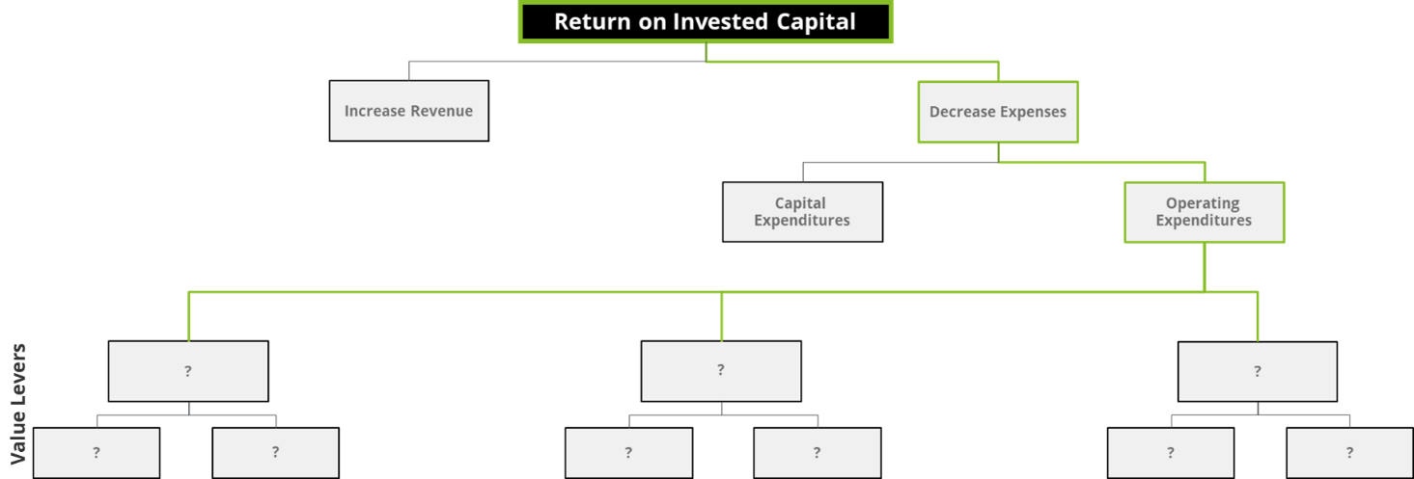

As you can see, your team has identified that you’re targeting a reduction in OpEx for the client, however the actual levers, which will be enabled, reducing cost through your proposed solution have not yet been identified. Your client, Sheri, has requested to meet with you to discuss your progress and the initial business case before the end of the quarter. You need to mobilize your team to complete the following: ***1)*** *Scope a strategy and/or solution, which your team recommends API deploy to address their maintenance-related expense issues,* ***2)*** *identify the 3 levers your solution or strategy will enable to reduce operating expenses,* ***3)*** *develop a list of quantitative and qualitative benefits aligned with each lever, and* ***4)*** *provide a ‘roll-up’ of quantitative benefits, which shows the amount(s) your team estimates API will realize over the next 5 years*. This will all be presented to Sheri and her team at the end of the quarter, then they will decide if they move forward with your firm on implementing the recommended strategies and/or solutions.

# **Scoping Your Solution**

In order to guide your team in scoping potential solution(s) or strategies to reduce operating expenses, you have developed the following visual. This visual depicts a simplified, end-to-end aircraft maintenance and repair process. Your proposed solution(s) and/or strategies should directly impact the accuracy or timing one or more of the activities below and should include people, processes, or technologies supporting these functional activities.

## ***Figure 1.1 – Aircraft Maintenance and Repair Process***

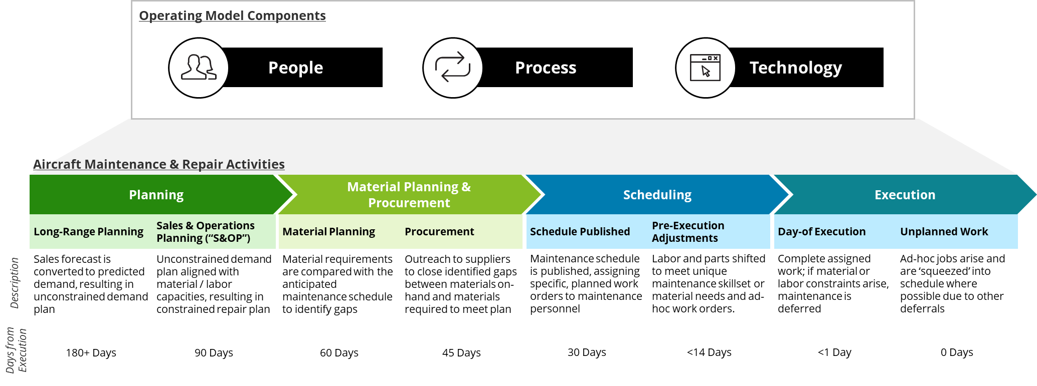

# **Your Options for Business Case Levers**

It is your responsibility to guide your team’s process and methodology in identify 3 levers, which align with your solution or strategy and sizing the 3 levers to present to Sheri & team. You develop an initial list of 5 potential levers, which you could align with your end-state solutions and/or strategies. You request and receive data from Sheri and team aligned with each lever, which you plan to include in your case. From past experience, you also know to support your estimates with external benchmarks (i.e., researching benefits others who have undergone similar solutions or strategies have realized). See below for the 5 potential levers you have developed to choose from.

### **Reduce Non-Operational Aircraft (“NOA”):**

Knowing your client’s primary goal with this program is to improve NOA performance. You could quantify the impact of improved performance (i.e., reducing day-to-day NOA). You have requested the client’s most recent NOA data. *See Figure 2.0.*

### **Adjust Fleet Mix:**

Maintenance material and labor requirements, along with recurrence of maintenance events often vary starkly between models of aircrafts within the fleet. You could investigate the impact(s) of changing the mix of aircrafts within API’s fleet. You have requested visibility into API’s current fleet mix. *See Figure 2.1.*

### **Reduce Expedite Fees:**

When maintenance spare parts and related materials are required, but are not available when/where maintenance will occur, they are often shipped as an expedite (i.e., API pays a fee to ship the materials as quickly as possible, as opposed to following the standard lead time). You could provide an estimate of the percentage impact your proposed solutions/strategies would have on aggregate material expedite fees. You have requested API’s most recent material expedite fee data. *See Figure 2.2.*

### **Reduce Work In Process (“WIP”) Inventory:**

WIP inventory is the total cost of unutilized goods currently stored and/or sitting idle at the end of each accounting period. You could provide an estimate of the percentage impact your proposed solutions/strategies would have on WIP inventory levels. You have requested API’s most recent WIP Inventory data. *See Figure 2.3.*

### **Reduce Hours Required to Complete Maintenance:**

Labor is a significant expense for many maintenance and repair organizations. You could provide an estimate of the percentage impact your proposed solutions/strategies would have on required labor. You have requested API’s most recent Labor cost data, but Sheri and team were not able to provide this data. If you decide to go this route, you will need to provide rational estimates and benchmarks within the case.

#### **Appendix: Supporting Data for each Potential Lever**

**Figure 2.0 – Past 3 Years AeroPro NOA Averages**

AeroPro Inc. Summarized NOA

|  |  |  |
| --- | --- | --- |
| **Year** | **Actual NOA / Day** | **NOA / Day Goal** |
| 2020 | 38 | 25 |
| 2021 | 35 | 25 |
| 2022 | 35 | 25 |

AeroPro Inc. Est. NOA Cost / Day1,2

|  |  |
| --- | --- |
| **ACFT Type** | **NOA Cost / Day** |
| Airbus A319 | $ 22,000 |
| Airbus A320 | $ 32,000 |
| Airbus A321 | $ 41,000 |
| Boeing 737-800 | $ 34,000 |
| Boeing 777-200 | $ 35,000 |
| Boeing 777-300 | $ 60,000 |
| Boeing 787-8 | $ 36,000 |
| Boeing 787-9 | $ 53,000 |
| **AVG Cost/Day** | **$ 39,125** |

*1Note: NOA Cost / Day estimates do not include material expedite fees, WIP Inventory, or Labor Expense data*

*2Note: NOA Cost / Day estimated are not weighted by size of the fleet or fleet mix*

**Figure 2.1 – Current AeroPro Inc. Fleet Mix**

|  |  |
| --- | --- |
| **ACFT Type** | **Current ACFT Count** |
| Airbus A319 | 135 |
| Airbus A320 | 48 |
| Airbus A321 | 290 |
| Boeing 737-800 | 350 |
| Boeing 777-200 | 23 |
| Boeing 777-300 | 45 |
| Boeing 787-8 | 40 |
| Boeing 787-9 | 19 |
| **TOTAL** | **950** |

**Figure 2.2 – 3-Year Average Expedite Volume and Fees by Carrier**

|  |  |  |  |  |
| --- | --- | --- | --- | --- |
|  | **Carrier 1** | **Carrier 2** | **Carrier 3** | **Carrier 4** |
| Shipments | 2100 | 1200 | 1100 | 2200 |
| Spend | $ 1,050,000 | $ 1,400,000 | $ 600,000 | $ 1,350,000 |
| Regions Covered | All Regions | Southwest | Northeast | All Regions |

**Figure 2.3 – 3-Year Average WIP Inventory Value by Spare Part Type**

|  |  |
| --- | --- |
| **Part Type** | **12-month avg** |
| Expendable | $ 1,200,000,000 |
| Repairable | $ 750,000,000 |
| Rotable | $ 2,000,000,000 |
| **TOTAL** | **$3,950,000,000** |